COLLABORATIVE MURAL PROJECT

As part of The World Games activities, we would like to invite your class/school/program to participate in a collaborative art project. You will need to identify 9 other classes/schools/programs to participate with you in this project. These partners may be in your school, system, program, your county, your state, other states, or if you choose other countries. Completed collaborative murals must be finished by April 2022, and a photograph of your mural submitted to the designated website.

For this project, you will need to use butcher paper that is 3 feet wide and 10 feet long. All 10 partners participating must use the same size paper for the mural. You will create a mural on this paper that reflects The World Games educational theme, “Live Healthy, Play Global.” You may have the students create their own art or you may create the mural art and have students complete it. Students may use paint, crayons,
watercolors, photos, collage, etc. to complete the mural. Each partner may use a different artwork and medium to create their mural. The only requirement is that the mural must reflect the theme.

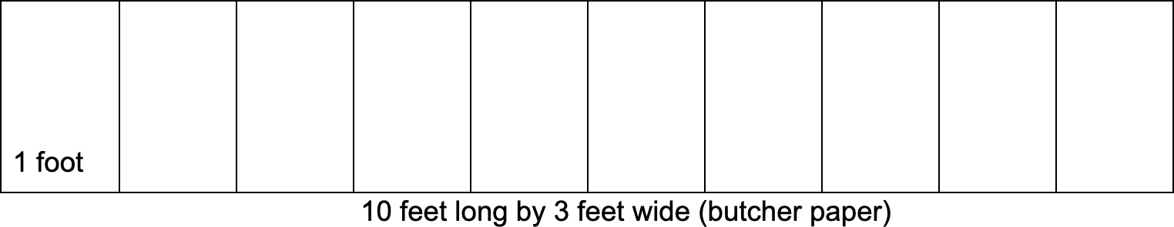

COLLABORATIVE MURAL PROJECT

Then, divide the mural into 10 one-foot sections and cut each section. Make sure to sign your class, school, or program name to all 10 sections of your mural. You will keep one section of your mural and then deliver or send one section of your mural to each of the 9 other classes, schools or programs that are collaborating with you.
Set a date to have the mural complete and a date to exchange or send the sections of the mural to each partner. Once you receive all 9 sections from your partners, work with the students to put your own one-foot section and the 9 other one-foot sections of the mural together to create a collaborative mural. When the mural is pieced together, have someone add the theme title, “Live Healthy, Play Global” across the mural.
Hang the mural in the hallway, lunchroom, entrance way, etc. so that others may view the completed project. Take a picture of your collaborative mural.

Photos of your completed collaborative mural may be uploaded to the website beginning March 1, 2022.

The World Games education committee will review all collaborative murals and will choose outstanding murals to be hung throughout The World Games Birmingham venues in July 2022.

Adaptations of the Collaborative Mural Project:
- If, for example, the YMCA wanted to work with 8 different program sites instead of 10, they would use 8, 1.25 sections.
- This project is based on an idea from Shannon McClintock and the Global Traveling Mural.
- View photos of their Global Traveling Mural Project here.

