SPONSORED BY
SWEDEN
POPULATION:
10.12 MILLION

AREA:
173,860 SQUARE MILES

CAPITOL:
STOCKHOLM

SOVEREIGNTY DATE:
JUNE 6, 1523

GDP:
538 BILLION USD

MEDIAN GROSS INCOME:
$487,977 KRONA / $50,514 USD

TOP EXPORT:
MACHINERY

FLOORBALL
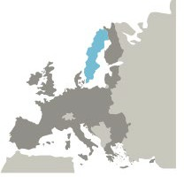
FROM GOTHENBURG, SWEDEN
While the origins of floorball have been heavily debated, the first floorball game happened in Gothenburg, Sweden in 1968, the first official floorball club was founded in Sweden in 1979 and by 1989 Sweden had the world’s first Floorball League. In Sweden the sport is know as “innebandy.” One thing that has helped floorball become popular quickly is the simplicity of the game. The game takes place on a “court” (which could
be indoors or outdoors) with only a ball and a floorball stick which looks a bit like a hockey stick. Because “checking” isn’t allowed in floorball, and the sport involves minimal contact, it is a game that is accessible to people of many ages and ability levels. In fact, wheelchair floorball is even a part of the International Floorball Championship. Thanks in part to its easy set-up and accessibility, floorball has become a beloved sport throughout the world. In fact, it is now played on every continent except for Antarctica!

BRIEF HISTORY OF SWEDEN
Sweden became a country in the year 1,000. This was a time when the Vikings were in power and moving eastward throughout Europe. In 1280, Sweden’s king Magnus Ladulas established a nobility and feudalistic society. After the Viking era, Swedes became connected to other countries around the Baltic Sea in a growing trade network known as the Hanseatic League. It is generally agreed by historians that by the late 13th century, Sweden was unified in some respects, with common laws throughout the land and one monarch. At this time the landmass of Sweden was composed of what is now southern Sweden, as well as parts of Finland.

In 1389, Sweden was united with Denmark through the Kalmar Union. A rebellion by 80 Swedish nobles in 1521 led to Sweden’s independence and the election of Sweden’s most famous king, Gustav Vasa. Sweden grew to become a dominant power in the Baltic and northern Europe beginning in the 1500s. Gustav Vasa also ushered the Protestant Reformation into Sweden, formally breaking with the Roman Catholic church in favor of the Lutheran Church.

In the 17th century, Sweden’s participation in the Thirty Years War led to a great expansion into the Baltic states. However, in 1721, a surprise attack from Russia resulted in the kingdom of Sweden losing its possession of
Estonia, Livonia, Ingria, and Karelia. Sweden eventually lost most of its conquered territories, but upon the election of one of Napolean’s marshals as its king, Sweden obtained Norway in 1814. The union was dissolved in 1905. Economic hard times hit the country in the 1800s and 1.5 million Swedes emigrated to North America. The 20th century brought rapid advancement in industry, the rise of democratic socialism, and a commitment to egalitarianism. Sweden was one of only a handful of countries to maintain neutrality during both World Wars. Through underground partnerships with neighboring Denmark, Sweden helped 90% of Danish Jews escape to neutral Sweden and survive the Holocaust.

Today, Sweden is a country of 10 million people who are probably best known around the world for IKEA, Pippi Longstocking, and ABBA.

GOVERNMENT
Sweden is a parliamentary democracy and a constitutional monarchy. Executive power is in the hands of the Prime Minister, however, the country also has a ceremonial royal family. While the royal family doesn’t play an active role in the governance of Sweden, they play an important role as ambassadors of the country and as symbolic leaders.

During Swedish elections, Swedes vote in favor of the party that they support, and the party then assigns members to seats in parliament in proportion to the vote that they received. Because Sweden has a multi-party system, in order to gain a clear majority in Parliament, many parties will join together and form “coalitions.” After the new coalition government is formed, a Prime Minister is nominated and voted upon by the whole of Parliament.

CIVICS & CITIZENSHIP
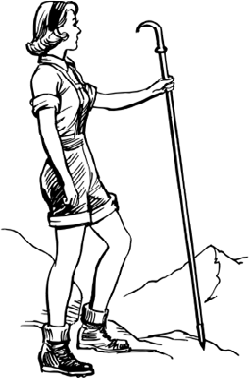
Swedish people hold their beautiful natural landscape in high regard. In fact there are over half a million primitive cottages, called “Sommarhus,” in Sweden where Swedish people spend their free time in the wilderness. Many Swedes even spend their whole summer living in these primitive cottages.
One law that allows them to enjoy nature to its fullest is “Allemansträtt” or “everyman’s right.” This legal provision means that everyone in Sweden (even visitors) are free to camp, fish, hike, ski, and generally enjoy all of the country’s land. Everyman’s Right functions on an honor system with an emphasis on responsibility and mutual respect for all, with an understanding that those who roam won’t harm the land or the landowner.

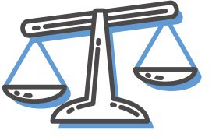
Swedes practice this idea of “lagom” which means “just the right amount— not too much and not too little.” The idea of lagom, and its
accompanying ideals of balance and moderation, inform the way Swedes work, vote, and interact with one another. These ideals are the opposite of a “supersize it” approach to life that communicates that “bigger is better.” Lagom informs Swedes’ commitment to sustainability and frugality.

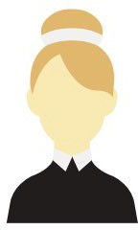
Did you know that in Sweden, women have had the right to vote in municipal (city) elections since 1862? While national suffrage (the right for all adults to vote in elections) didn’t occur in Sweden until the country’s 1921
election, equality for all genders has remained an important part of Swedish culture. In fact, during the 1921 election five women were elected to parliament! Today, women make up 47.7% of the total workforce in Sweden— one of the highest rates in the world.

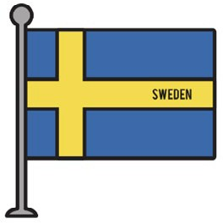
Celebrated on June 6th, Sweden celebrates its formal independence from Denmark, which occurred in 1523. Like many countries, Sweden not only celebrates their sovereignty on their independence day, but they also use the day to welcome newly naturalized Swedes to the country during special ceremonies. It is typical for children to dress in traditional Swedish peasant costumes and for Swedes to display their country’s blue and yellow flag. The country’s King and Queen, who play only a ceremonial role now, participate as well.

