HOW TO HOST A THE WORLD GAMES

INTERNATIONAL FESTIVAL
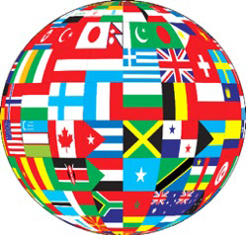
These are some general guidelines that have proven to shape a successful The World Games International Festival. You have the creative control to do what is necessary for your school or class.

- Mission: To celebrate the diverse cultures represented in The World Games. THINK GLOBALLY!

- Who can be involved: EVERYONE!

- Committee: Select a support team of teachers, support staff, volunteers (including a community pillar and parents) that are enthusiastic about the cause and willing to drive the festival from the beginning to end. Your team should include ESL staff, at least 1 teacher from each grade level in your school, your school bookkeeper and an officer from your PTA.

- Timelines: Give at least 3 months for planning, ordering, connecting and advertising. Consider you will need to order supplies, connect with community shareholders, allow time for teachers to plan activities and students to learn and be engaged.

  - The Essentials: Think Authentic Engagement, Think Globally

Countries, provinces, territories etc. that are represented in The World Games should be recognized and celebrated.

Designate a space – Such as an auditorium, cafeteria or school gym – and table or booth space for groups (by grade levels or individuals) to set up a decorative, inviting and informational display about a chosen country. The display could include (but not be limited to) the country flag and other national symbolic pieces, native foods, candies or popular trinkets, clothing, instruments and music, pamphlets, holiday items, jewelry or historical artifacts. Whoever is in charge of the booth is responsible for creating the
space they want. Grade levels would reach out to students and parents for their help and contributions to the booth/table. Each display area should be colorful, inviting and make it interactive. Begin preparing for the festival, by having students research the country or countries the class will showcase. Students could create artwork, participate in dances and music representing different cultures, teachers or parents can read stories from different countries, help with crafts, donate native games, items or books etc.
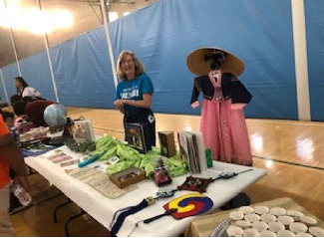
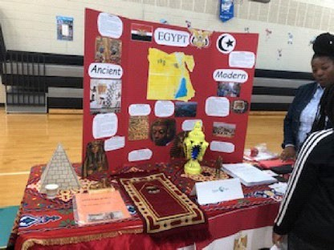
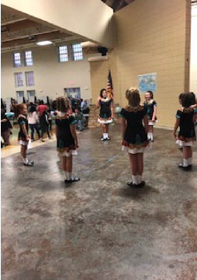
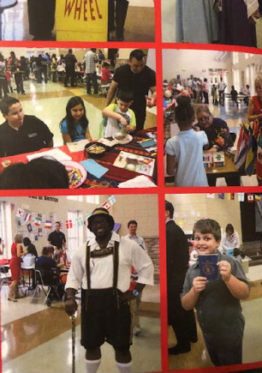
Interactive activities ALWAYS add value to your festival.

